System Requirements
First ,In My Automation system for cargo program ,you need to enter who you are.For example,If you are an administartor then you need to enter administrator,if you are a customer then you need to enter customer and so on.
If Customer enter the program then ,Customer have to enter with the tracking number that is given to customer to program if Customer wants to see the imformation about him/her.
Administrators can add branches,branch employees and transportation employees and remove them.
Branch employees can add cargos and customers and remove cargos and customers.
Transportation personel can only update status of cargos.
If Branch employees want to see cargos or customers , you enter first which branch,then enter which employee after that you can see cargos becouse ,Since branch employees can add cargos and customers ,cargos and customers array in Branch Employees’ Class.
If Branch employees want to record the cargos then should enter add cargo but if Branch Employees want to add only a customer then should enter add customer becouse cargos and customers are different.
If Branch employees want customers to see imformetion about their cargos , then Branch employees enter add cargos but just want to record only customers then enter add customer.

Non-functional requiremnets : Performance ,Speed ,Capacity

Use Case Diagram

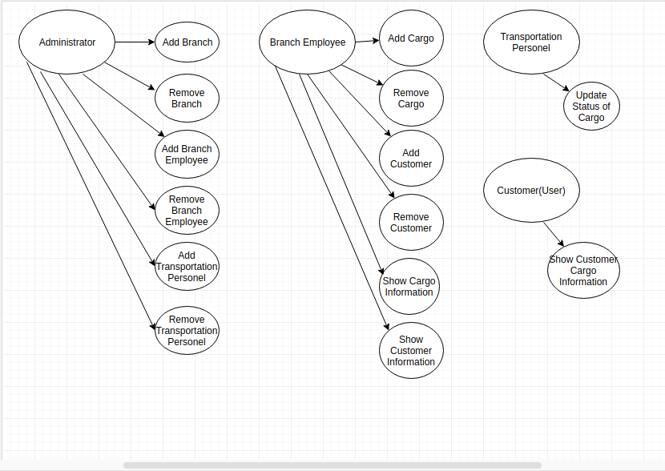

Class Diagram

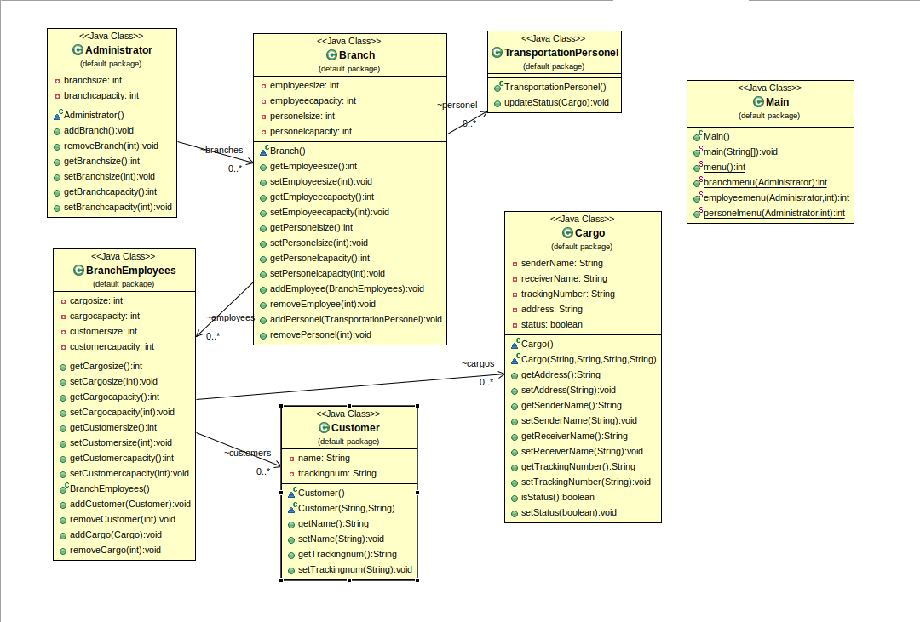
Problem Solution Approach
When The problem came me , I thought that There will be a menu that Administrator, Branch Employee, Transportation Employee and Customer could enter. Then for this menu , I made Classes that are Administrator, Branch, BranchEmployee, TransportationPersonel, Cargo ,Customer and Main.After that, I thought that If Administrator can add and remove branch then it should have branch array.Administrator can add Branch employee and Transportation personel but I put rmployee and personel arrays in branch class becouse every branch has own branch employee and trasportation personel.Then I wrote Branch Employee and Transportation Personel Class .Since Branch Employees enter the cargos into the system , I put cargo array and customer array in branch employees class.Becouse In same branch every branch employee enters own cargo and own customer then I thought that .So If Branch Employee wants to remove cargo then he/she enter branch employee in menu then select himself/herself in second menu then he/she can remove his/her cargo.I thought customers and cargos are different array.Becouse I though that Branch Employees record cargos to send them and record customer so that The imfomations about customers stay in branch. As a result , I approach the problem very closely that I wrote.

Test Cases

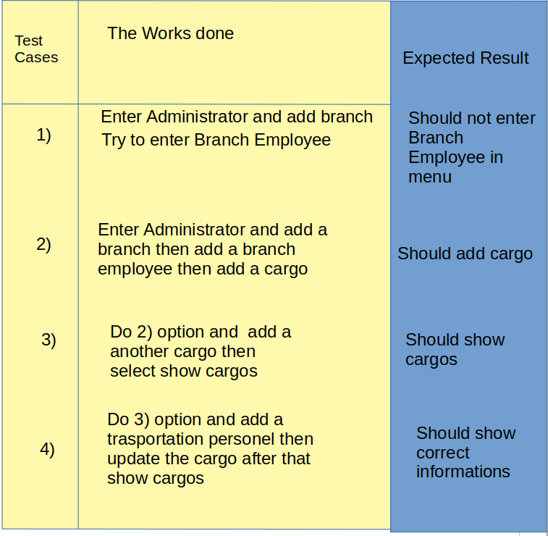

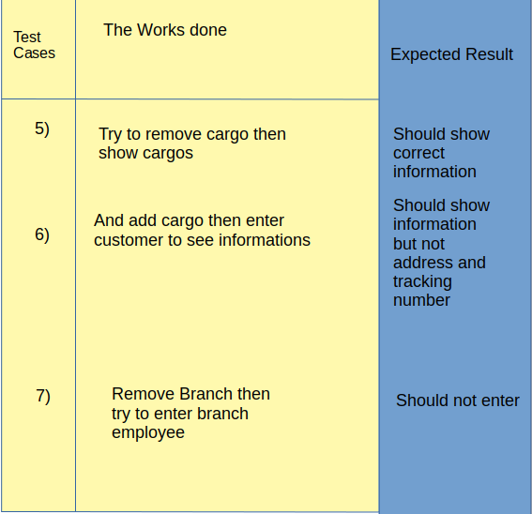

Running Command and Results

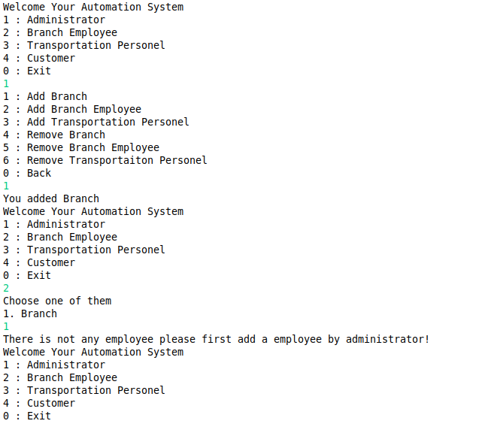
Output Case 1)

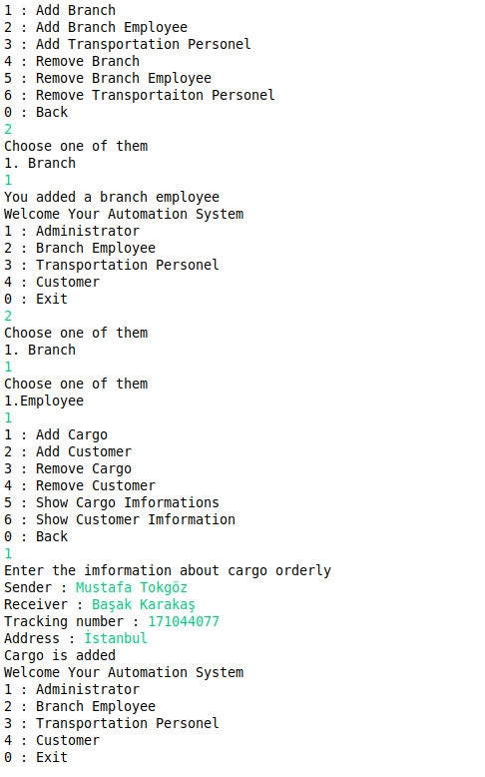
Output Case 2)

Output Case 3)
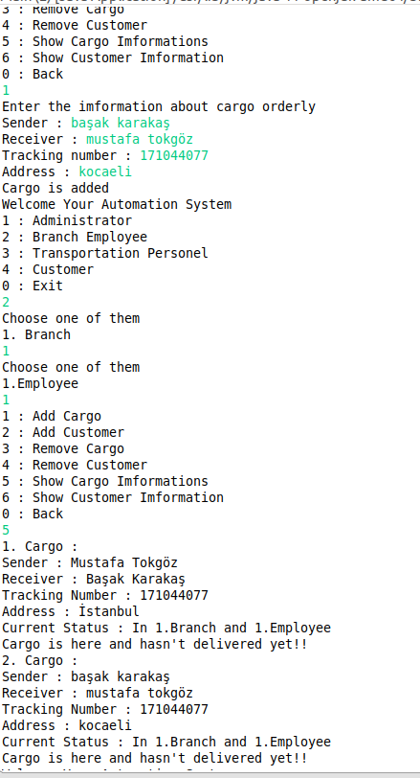

Output Case 4)
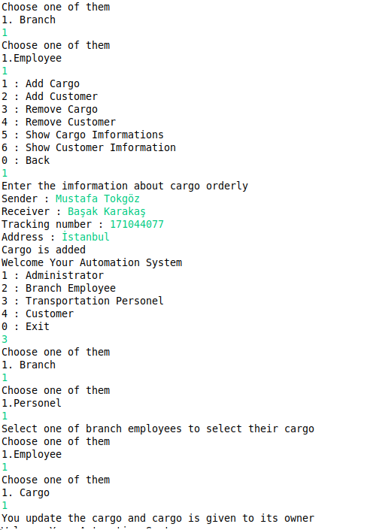

Output Case 5)
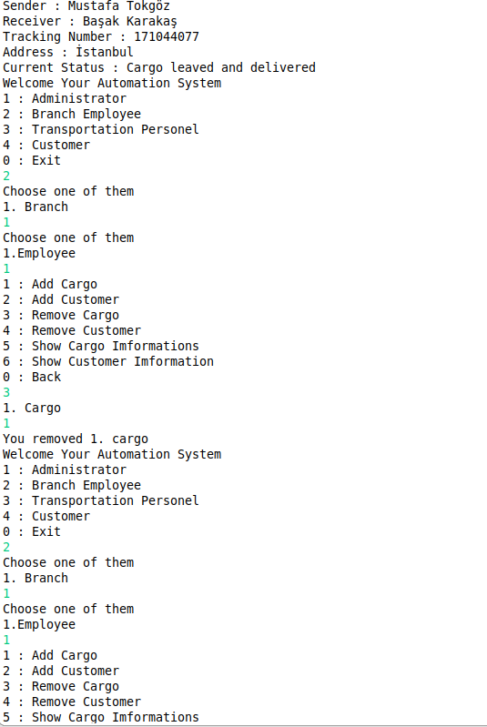

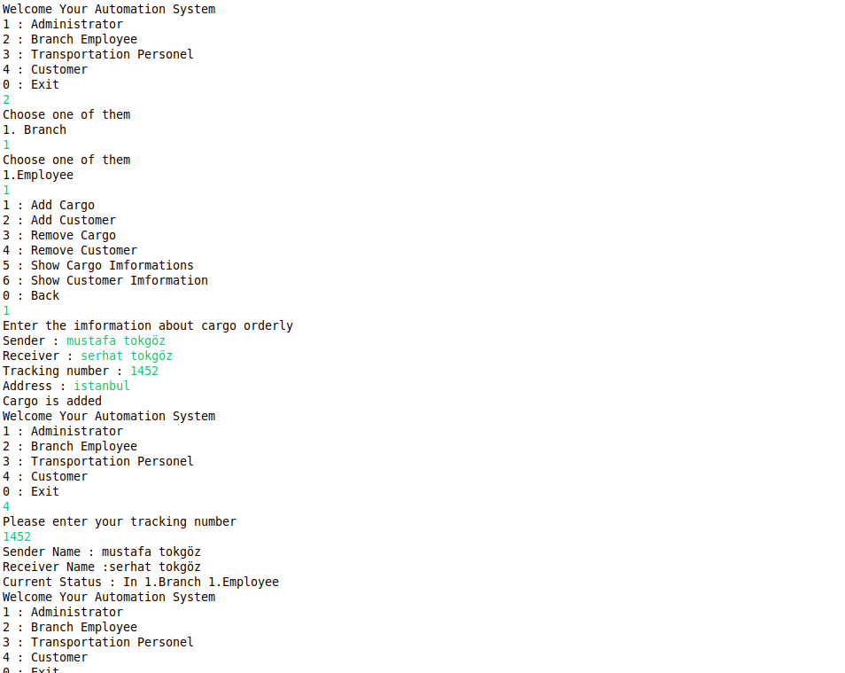
Output Case 6)

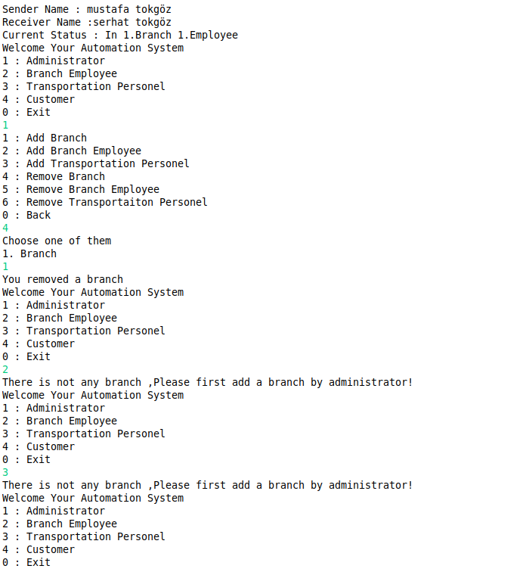
Output Case 7)

Mustafa Tokgöz 171044077

